System Narrative
BAX India Direct Ship
Version 1.5

Modification History

Version No. | Modified By, Date | Description
1.0 | August 2, 2005, Jocelyn Austria | Draft
1.2 | August 3, 2005, Jocelyn Austria | Additional column in bax_pricemaster
1.3 | August 10, 2005, Jocelyn Austria | Import month and manufacturer month -- comment given by Apple ;  Include Joey’s comment re bax_pricemaster_history.price import & email notification availability
1.4 | August 15, 2005, Jocelyn Austria | Use POE as the ship to address for the commercial invoice
1.5 | August 17, 2005 | Phase I. Import Month = Manufacturing month  and some minor changes on the MRP label

Review and Sign off

The following parties have confirmed and reviewed the specifications presented in this document against selected business processes to be implemented as stated in the Business Narratives.

Contents are subjected to change pending further review and revision of this document

Apple Review List |  | Version 1.0
Name | Title | Signature/Date

BAX Review List |  | Version 1.0
Name | Title | Signature/Date
Table of Contents

1. Introduction 5
1.1. Objective 5
1.2. Abbreviation 5
1.3. Facts 5
2. WMS Implementation 5
2.1. Master Data Setup 5
2.1.1. Storer 5
2.1.2. SKU 6
2.1.3. Codelkup table 6
2.2. Data Mapping in Exceed 7
2.2.1. Outbound tables 7
3. Outbound 9
3.1.1. Price Label Function Program 9
3.1.2. Price Master File Screen 10
3.1.3. Exception Report 11
3.1.4. Price Label - Print 11

Introduction

Objective
The objective of this document is to provide the comprehensive printing solution to support BAX India Direct Ship.

Abbreviation

Acronym | Full name | Remark
POE | Port of Entry
MRP | Maximum Retail Price

General Flow
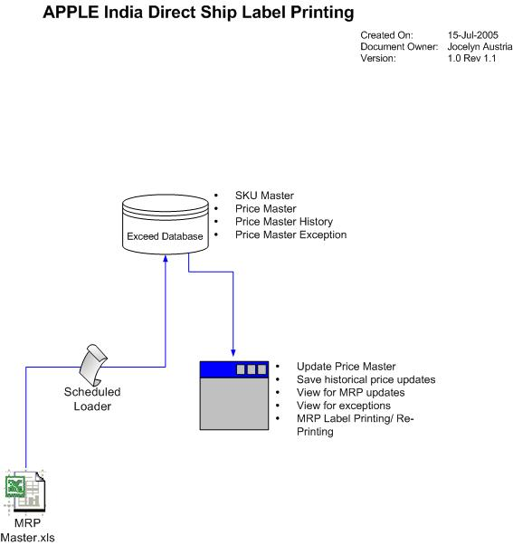

Facts
The information provided in this document has been provided based on the information provided by Apple

- Apple shall send the pricing information in a tab-delimited format based on an agreed format (see attachment below)
- Part number description shall be taken from the 850 EDI message
- BAX should use the latest price.
Scenario :
June 1 - BAX received the file for partnumber A as USD100.
June 2 – BAX receives the file but the partnumber A is not found. Use the previous price provided for the particular partnumber
- POE shall be a mandatory information in the 940 EDI message .
- Each single box should have a label. This means BAX open the multipack and paste the label on each and every pack
- All boxes should have an SRP label and physical ship-out is not possible.

WMS Implementation

Master Data Setup

Storer
Table Name: Storer

Data Field | Exceed Field | Exceed Screen | Remarks
Storer | Storerkey | Storer | 1320
Type | Type | Type | Value as ‘Storer’ (1)
Company | Company | Company
Address1 | Address line 1 | Address line 1
Address2 | Address line 2 | Address Line2

Note :

Taken from Logistics Master Data ver 3.1.6 under Sales Organization

11 | 1320 | Apple Computer International Private Limited  5th Floor, Du Parc Trinity,  #17 M.G. Road, Bangalore 560 001, India | BLR | 91-80-555-0575
 | BLR | Apple c/o BAX Bangalore  30/1, 1st stage, 1st Cross, Michael Palya, 80 FT Road, Indiranagar, Bangalore - 560038 | BLR
 | HYD | BAX Global India PVT Ltd – Warehouse  Door No : 1-8-115/2/1,  Machodguda, Adj. Wesley Boys High School  Secunderabad : 500003 | HYD
 | CCU | BAX Global India Pvt Ltd  2A, Satya Doctor Road  Near Martin Burn Plot  Calcutta – 700023 | CCU
 | BOM | BAX Global India Ptv Ltd  Plot No 3, Jawahar Industrial Co Estate  Nr M.G.M College, Village Kamote  Kalamboli Panvel 410209 | BOM
 | DEL | BAX Global India Pvt Ltd.,  Killa No. 18/1 Revenue Estate,  Near Karan Dharam Kanta,  Village Samalkha  New Delhi, 110037 | DEL
 | Chenai | BAX Global India PVT Ltd  117, GNT Road, Ponniammanmedu Post,  Madhavaram, Chennai 600 110 | MAA

SKU
Table Name: SKU

Data Field | Exceed Field | Exceed Screen | Remarks
Storerkey | Storerkey | Storer
SKU | SKU | Commodity
Description | Descr | Description
Note :

Information in SKU table is automatically populated using 850 EDI message provided by Apple

Codelkup table

Data Field | Exceed Field | Exceed Screen | Remarks
Reason  DUP –duplicate partnumber  NOSKU – Missing partnumber | Listname | MRPPBCode | MRP problem code

Serialno - Manufacturing Month Computation
***** Applied on Phase 2. During go-live, import month = manufacturing month.

Position 3 – Manufacturing Year
Position 4 and 5 – manufacturing week

Example :

Serial is JQ5076JKSAY

manufacturing year 2005
manufacturing week 07
manufacturing month November (based on Apple workweek calendar, refer to Appendix c)

Data Mapping in Exceed

Outbound tables

Table Name: BAX_PriceMaster

Data Field | BAX WMS DB field | Excel Column Position | Remarks
ImportID | ImportID
Part No | Partnumber | Column 1
MRP | Price | Column 3
Tax | Tax |  | Derived value ** for future requirement
TTL_Price | TTL_Price |  | Derived value (price + tax) ** for future requirement
LabelPrint | LabelPrint
Reference1 | Reference1
Reference2 | Reference2
Adddate | Adddate |  | Date imported to system yyyy-mm-dd hh:mm
Add_who | Add_who
Editdate | Editdate |  | Date imported to system yyyy-mm-dd hh:mm
Edit_Who | Edit_Who

Table Name: BAX_PriceMaster_History (primary key: partnumber + Adddate)

Data Field | BAX WMS DB field | Excel Column | Data Type | Remarks
ImportID | ImportID |  | Varchar | Bax_pricemaster.importid
File | Filename |  | Varchar
Partnumber | Partnumber | Partnumber | Varchar | Bax_pricemaster.partnumber
Price | Price | MRP | Float | Bax_pricemaster.price
Adddate | Adddate |  | Datetime | Yyyy-mm-dd hh:mm  Taken from bax_pricemaster.editdate

Table Name: BAX_PriceMaster_Excp

Data Field | BAX WMS DB field | Excel Column | Data Type | Remarks
File | Filename |  | Varchar
Partnumber | Partnumber | Partnumber | Varchar
Price | Price | MRP | Float
Adddate | Adddate |  | Datetime | Yyyy-mm-dd hh:mm
Reason | Reason |  | Varchar

Table Name: BAX_AppleSLA

Data Field | BAX WMS DB field | Values | Remarks
Origin | Origin | SIN | Default value ‘SIN’
Destination | Destination | DEL  BOM  HYD  MAA  CCU  BLR
Mode | Mode
SLA | SLA | Based on the appendix A per each destination

Table Name: BAX_AppleWW

Data Field | BAX WMS DB field | Values | Remarks
Year | Year |  | Format yyyy thus if serialno position 3 is express as ‘5’, convert to become 2005
Workweek | Workweek | Based on Apple workweek calendar
Month | Month | Based on Apple workweek calendar

Outbound

Price Label Function Program
- Import program to upload excel spreadsheet into system –
- Print Exception Report
- Print MRP labels

File format for Price Label

File Format (text file/excel/etc): | Tab-delimited
Filenaming Convention:
Mode of transport (email/ftp/etc): | FTP
FTP site | Ftpgw.baxasiapac.com
Folder | Apple\Incoming\MRP
Import Method (manual/scheduled): | Scheduled
Import Program (Exceed EC/Hub Appln/Customised): | Customised
Import Frequency: | Once a month

File Format – mapping of fields needed

S/no | BAX WMS DB Field | Data Type | Max DB  Length | BAX Mandatory fields | Customer’s System | Mandatory Fields | Description/Remarks
 | BAX_PriceMaster.partnumber | Char | 20 | Y | PartNo | Y | Column position 1
 | BAX_PriceMaster.Price | Float | 10 | Y | MRP | Y | Column 3  No comma
 | NA |  |  |  | Description | N | Discard upon import (column 2)
S
For testing purpose, refer to 

File Import logic
Import the following tab-delimited format with the following checks:
- Do not import for duplicate partnumber and update bax_pricemaster_excp where reasoncode = ‘DUP’
- Check that all mandatory fields are present – refer to BAX Mandatory field column
- If successfully imported, assign importID.
- If partnumber is not existing in BAX sku table, do not import in bax_pricemaster.SKU and update bax_pricemaster_excp where reasoncode =’NOSKU’
- If partnumber is existing in BAX sku table and is found in bax_pricemaster.sku, update editdate, adddate and price in bax_pricemaster table. Update editdate.
  - Get max(bax_pricemaster.editdate) and insert into bax_pricemaster_history and update adddate
- Discard column 2 from being imported to bax_pricemaster table.
- When an SKU is successfully imported in bax_pricemaster, check if SKU is existing in BAX_pricemaster_history. If existing
  - Move the old price record in bax_pricemaster and replace existing record in bax_pricemaster_history
  - Maintain one record of the same SKU in the bax_pricemaster_history
  - Send an email message to concerned personnel of the imported price master. (need to check with Joey the content of the message when an email message is sent )

Bax_pricemaster |  |  | Bax_pricemaster_history
SKU | addDate | Price | SKU | addDate | Price
SKUA | 8/1/2005 | 100
SKUA | 8/2/2005 | 200 | SKUA | 8/1/2005 | 100
SKUA | 8/3/2005 | 300 | SKUA | 8/2/2005 | 200 (current entry)

Price Master File Screen

View – create a screen with the following fields.

Line # | SKU (bax_price master.sku) | New Import Date/Time (bax_pricemaster.adddate) | New Price (bax_pricemaster.price) | Last Import date/Time (bax_pricemaster_history.adddate | Old Price  (Bax_pricemaster_history.price)
1 | M9687FE/A | 2005-08-02 11:30 | 34901 | 2005-08-01 11:30 | 34900
2 | M9843SA/A | 2005-08-02 11:31 | 78401 | 2005-08-01 11:31 | 78400
3 | M9834SA/A | 2005-08-02 11:31 | 53201 | 2005-08-01 11:31 | 53200
4 | M9835SA/A | 2005-08-02 11:31 | 53201 | 2005-08-01 11:31 | 53200

Retrieval Criteria
- Partnumber
- ImportDate

Data Extraction Logic
- Retrieve from BAX_PriceMaster and BAX_PriceMAster_History
- Sort by partnumber

Database Table
Refer to table : BAX_PriceMaster and BAX_PriceMaster_History

Exception Report

Retrieval Criteria
- ImportDate

Data Extraction Logic
- Retrieve from BAX_PriceMaster_Excp
- Sort by partnumber
- Exception report is sent automatically to BAX via email in text format

Report Format

Partnumber | MRP | Date import | Reason
Bax_pricemaster_excp.partnumber | Bax_pricemaster_excp.price | Bax_pricemaster_excp.adddate | Bax_pricemaster_excp.reason

Price Label - Print

Retrieval Criteria
- ShipTo
- DeliveryNumber

Data Extraction Logic
- Retrieve from BAX_PriceMaster , Orders, Orderdetail, Storerkey and SKU
- Sort by DN, sku

View

Delivery # | Line# | SKU | Qty | Shipdate | Wavekey
Orders.externorderkey | Orderdetail.externlineno | Orderdetail.sku | Orderdetail.qtyallocated | Orders.adddate | Pickdetail.

Print Logic

- Check if orders.s_country = ‘IN’ and POE is not null then proceed to print MRP label .
- Print MRP label
  - based on the orderdetail.allocatedqty
Example DN 801234567 with allocatedqty= 10. Print 10 MRP label
  - If orderdetail.sku is existing in bax_pricemaster.partnumber.
  - When orders.status = ‘Normal’ and orderdetail.allocatedqty <> ‘0’. Once printed, update bax_printmaster.labelprint = ‘Y’.

How do we handle re-printing of MRP label ?

Label Format
Label size is 7x3.8cm

Part No | Description | MRP | Importer **** fixed value | Import Month  **** Format : Full monthname yyyy | Mfg Month | Manufacturer *** fixed value | Apple  Logo
<orderdetail.sku> | <sku.descr> | Bax_pricemaster.price + concatenate “(Inclu., of all taxes)” | Storer.storerkey where storekey = ‘1320’ | Orders.adddate + bax_appleSLA.SLA by POE | Refer to Section 2.2 under Serialno | Storer.storerkey where storerkey = ‘6401’

Note for manufacturing month

Phase 1 : Import month = manufacturing month
Phase 2 : Apply serialno logic refer to section 2.2

Sample

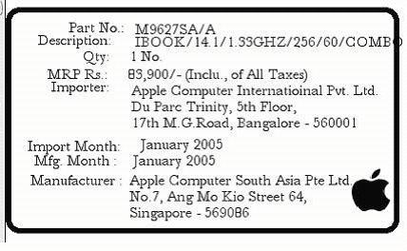

Note :

If orders.s_country = ‘IN’ and bax_pricemaster.labelprint = ‘Y’, change orders.status = ‘Shipped’ when perform system ship. If not, do not perform system shipped and prompt error message “Print MRP label”.

Commercial Invoice

Ship to code should be according to POE as stated in Section 2.1.1.

Appendix A – Cycle Time SLA (taken from SOW given by Apple)

Origin | Destination | Mode | SLA | Remarks
Singapore | Bangalore (BLR) | Air | Day 4 | D0 Pick up
Singapore | Delhi (DEL) | Air | Day 4 | D0 Pick up
Singapore | Mumbai (BOM) | Air | Day 4 | D0 Pick up
Singapore | Kolkata (CCU) | Air | Day 4 | D0 Pick up
Singapore | Hyderabad (HYD) | Air | Day 4 | D0 Pick up
Singapore | Chennai (MAA) | Air | Day 4 | D0 Pick up

Appendix B – Apple WorkWeek calendar
